# How to use ESCAP Carbon Pricing Simulation tool

# How to access and start the simulation tool

The simulation tool can be accessed by clicking [here](https://mybinder.org/v2/gh/IbHansen/UNESCAP-Asia/HEAD?urlpath=tree/Asia/Carbon%20tax%20experiments%20singel%20country.ipynb) or by clicking on the link below:

https://mybinder.org/v2/gh/IbHansen/UNESCAP-Asia/HEAD?urlpath=tree/Asia/Carbon%20tax%20experiments%20singel%20country.ipynb

A new tab will open in your browser, and after a small delay it should look like the image below:

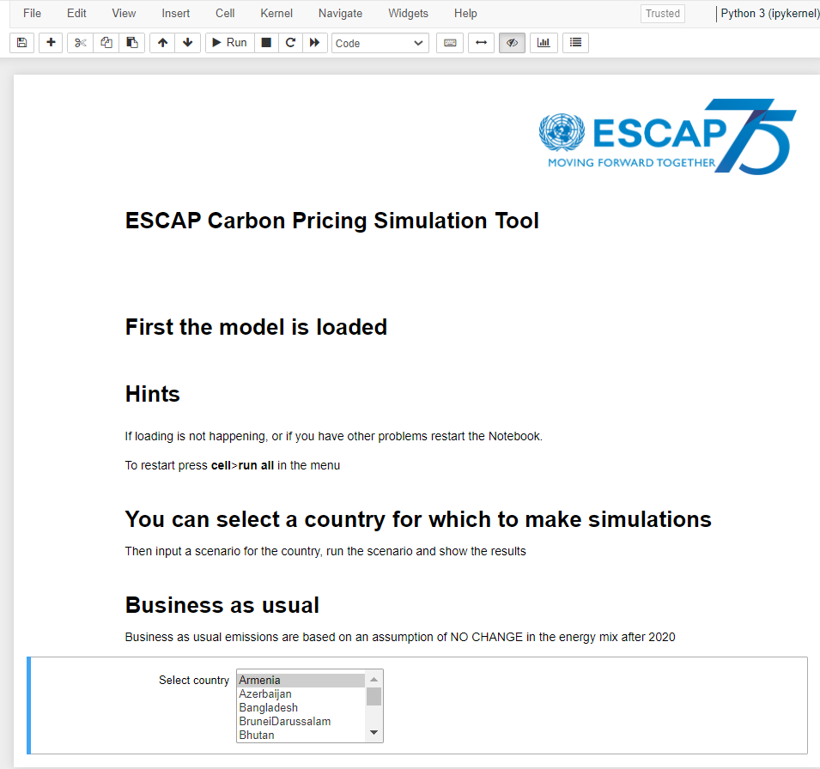

It can take some time for the tool to appear. First **a virtual machine/virtual notebook** is created, then the economic model is loaded. The time for this will depend on server capacity usage.

## How to choose parameters/inputs for each simulation session

Once the model is loaded, the user can choose a country from a list of countries provided.

When a country is selected, three parameter tabs will appear as shown below.

Each tab can be expanded to show a choice of policy options.

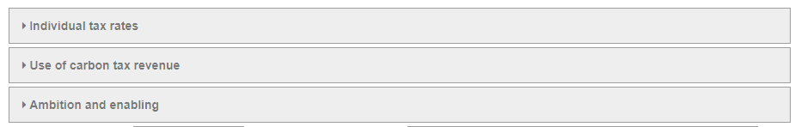

## 

## Individual tax rates

This tab allows the user to select/define the changes in carbon tax rates on an annual basis. The tax rate is measures in USD per tonne CO2e.

Note that the input is the change in the rate. So, an value of 5 USD in 2021 will result in 5 USD higher tax rate in every year from 2021 and onwards. If in addition a value of 5 USD is used for 2022 the tax rate in 2021 will be higher with 5 USD and from 2022 onwards with 10 USD.

As an example, we can look at Indonesia and input 5 in the first 5 years,

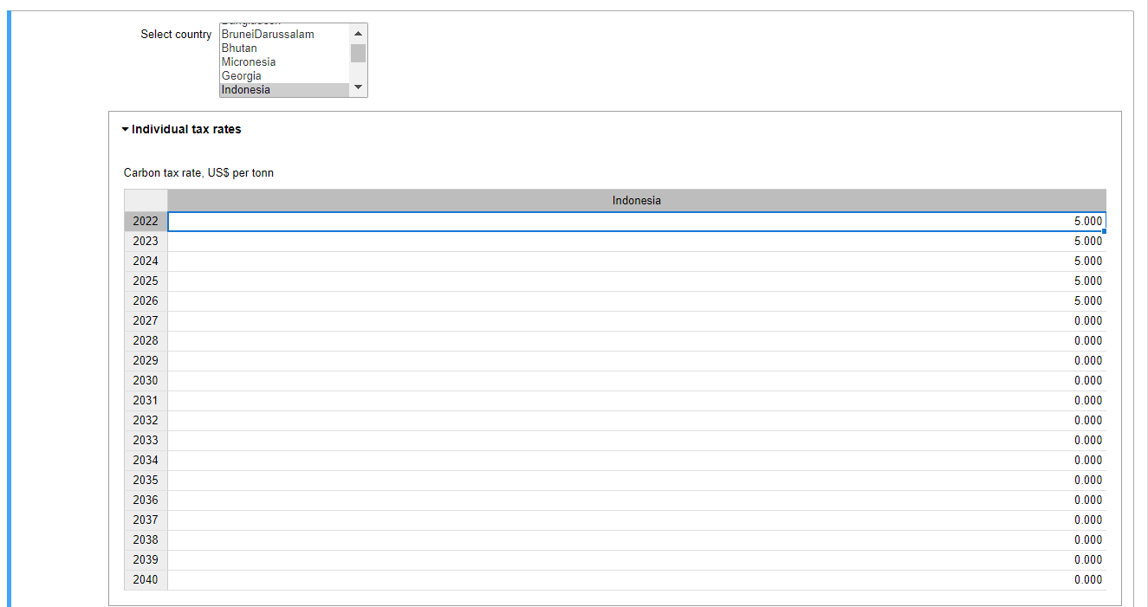

**Use of carbon tax revenue**

This tab provides various options for the user to decide how to use the tax revenue among several fiscal policy areas as described below.

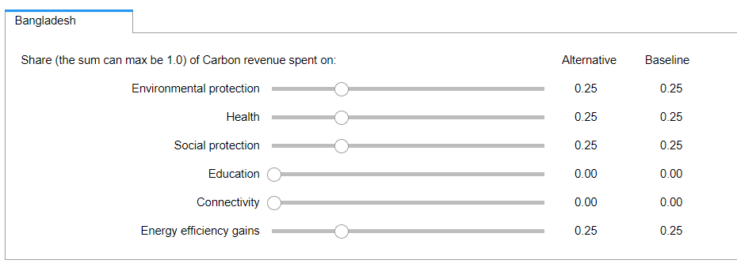

Note that the total sum of shares can only be a maximum of 1 and cannot go negative for any of those policies. The tool enforces those constraints.

**Ambition and enabling**

This tab allows the user to select additional ambition and enabling scoring parameters. The starting value is the current parameter value for each Asia-Pacific country, as defined in the recent joint assessment report of ESCAP, UNEP, UN Women and the greenwerk[1]. The values of those two parameters can be selected between a minimum of 1 and a maximum of 5.

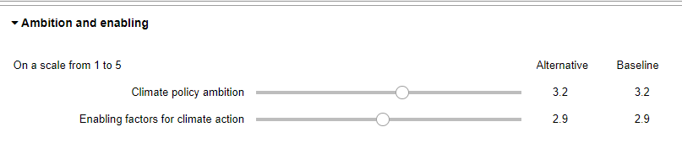

## How to run the simulation

As a default, the tool will suggest a scenario name when the input for a scenario has been updated. It might be useful to identify a more descriptive title for the scenario. The title of the scenario can be changed as indicated below:



Note that this will be the scenario title, which will appear in the resulting chart, so it is important to select a more descriptive title.

Now the scenario can be simulated by pressing this button:



## Review results

When the model has completed the simulation, a resulting chart will be generated and shown. The user can select indicators to chart from this dropdown box (in this example for Bangladesh):

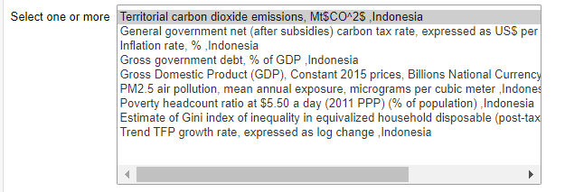

This shows the default chart after a simulation where the tax is increased by 5 USD/tonne CO2e for each of the first 5 years.

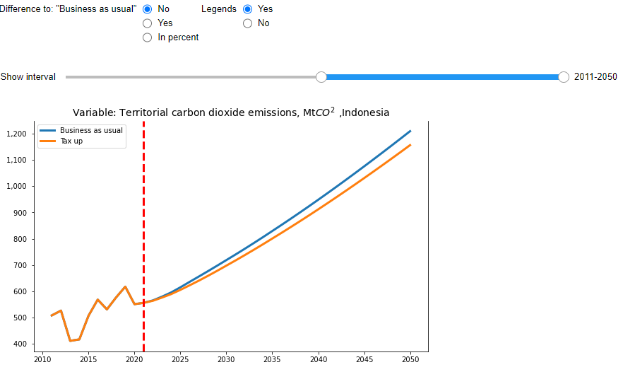

For some parameters/indicators it can be more relevant to compare with the "Business as usual" projection either in absolute terms or as a percentage ratio to the "Business as usual".

Those options can be selected using the appropriate button in the “Difference to Business as usual” list as shown below:

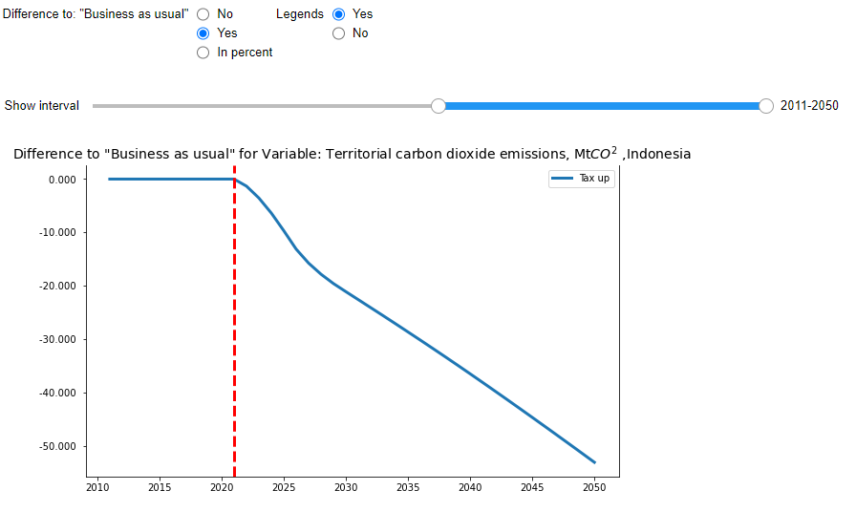

This is the graph generated when percentage to Business as usual is selected:

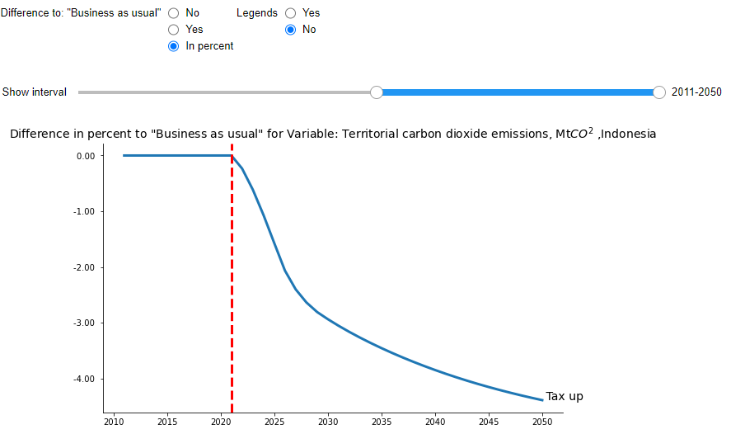

The legend button determines the placement of the scenario text. Either to the right of the scenario results, or in a legend box.

## To start a new country simulation session

To start a new country simulation session, it is necessary to clear all previous results for this country. This is done by first selecting another country and then returning to the initial country of choice.

## Trouble shooting.

If something goes wrong the user would need to restart the **virtual notebook**. This is done from the menu bar by selecting **Cell>run All** as shown below:

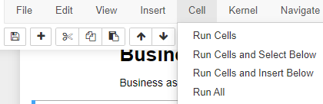

Click

Another option will be to restart the uploading of the tool again by clicking [here](https://mybinder.org/v2/gh/IbHansen/UNESCAP-Asia/HEAD?urlpath=tree/Asia/Carbon%20tax%20experiments%20singel%20country.ipynb) or by using the link below:

https://mybinder.org/v2/gh/IbHansen/UNESCAP-Asia/HEAD?urlpath=tree/Asia/Carbon%20tax%20experiments%20singel%20country.ipynb

1. https://www.unescap.org/kp/2021/15degc-within-reach-asia-pacific-region-ambition-and-potential-ndc-commitments-asia-pacific